//sum of digits

echo "Enter the num : "
read n
temp=0
sum=0
while (( n>0 ))
do
temp=$(($n%10))
sum=$(($sum+$temp))
n=$(($n/10))
done
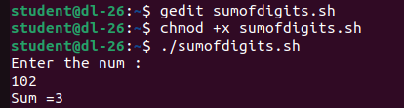
echo "Sum =$sum "

